**Probability project**

**Khaled Osama Abdel Hamid 201600515**

**Part 1**

1. 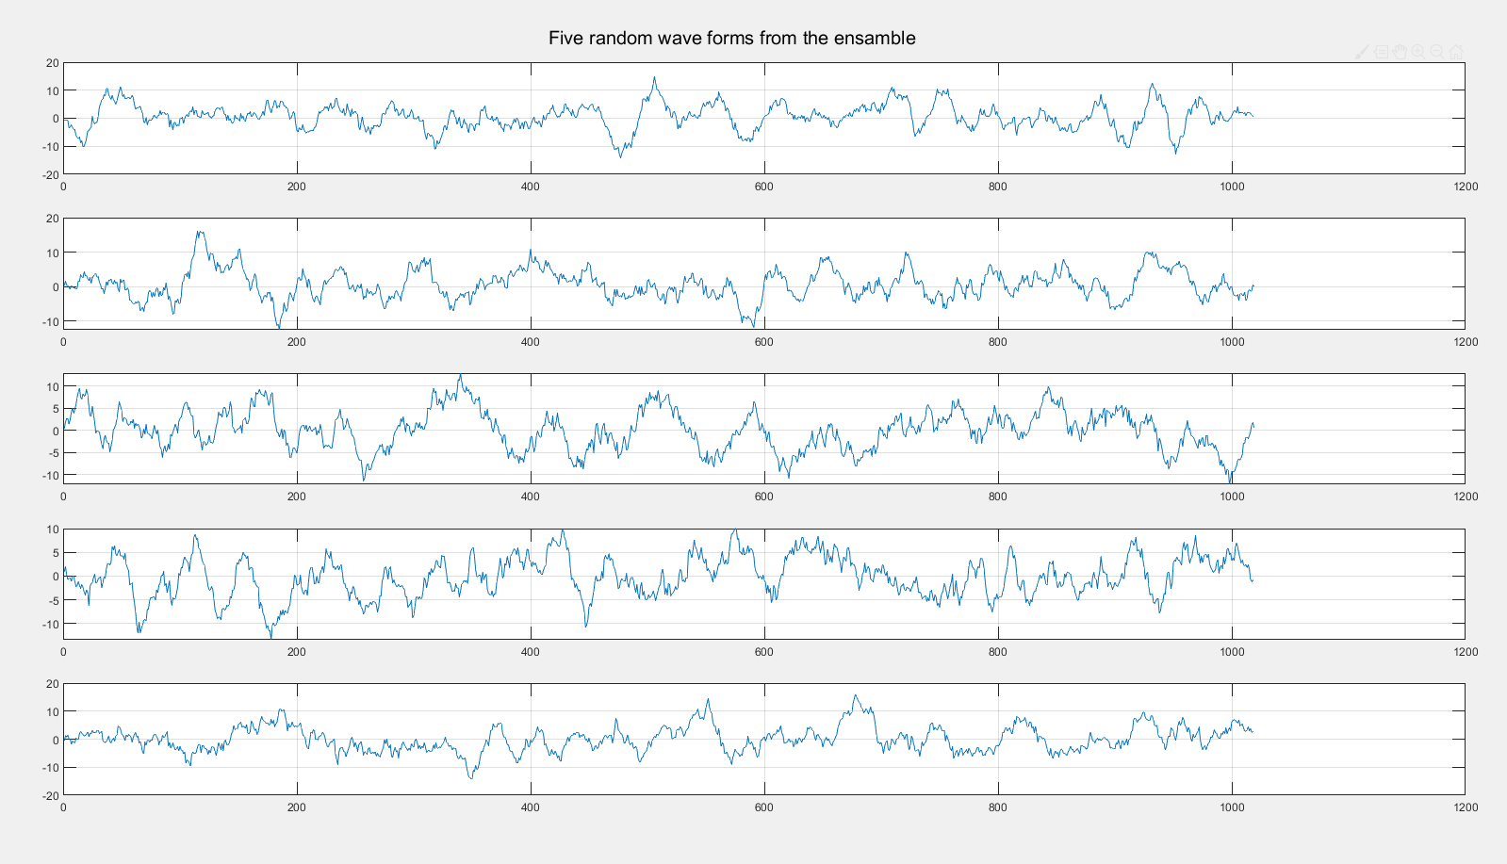**5 sample plots:**
2. 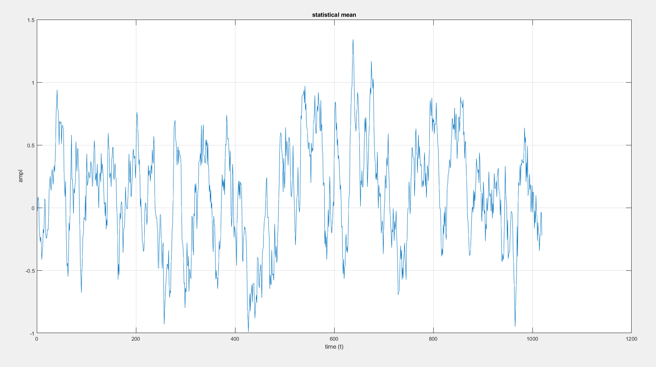**Statistical mean**

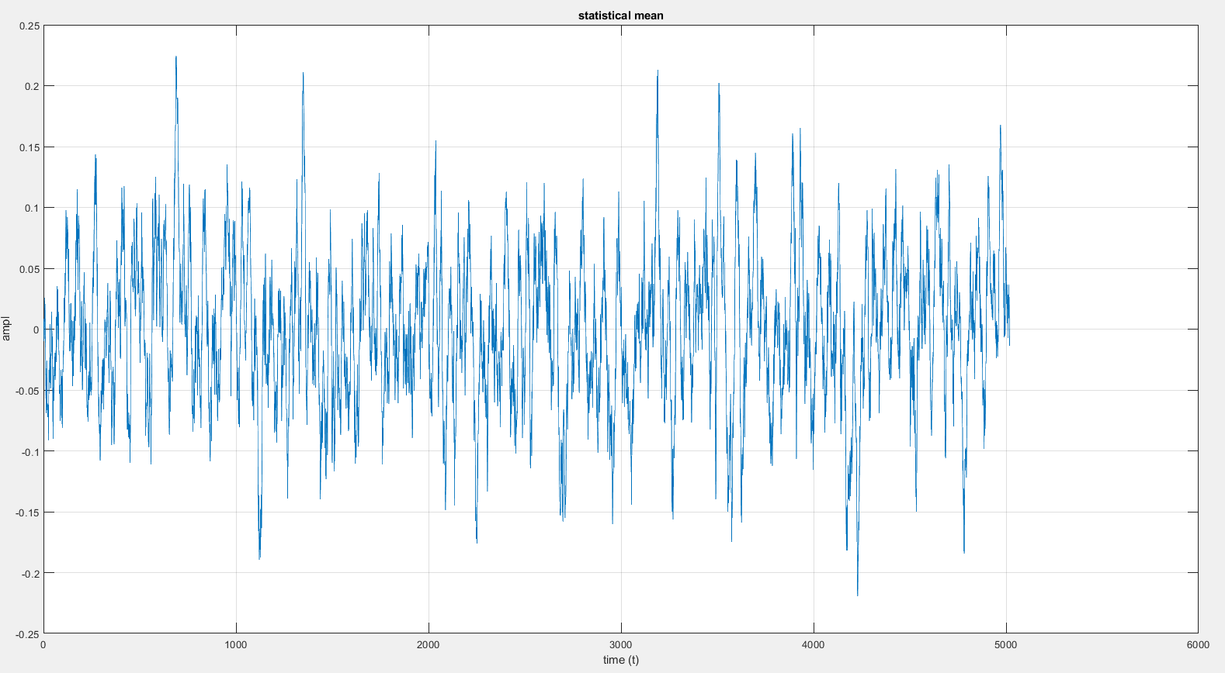Please note that because the ensemble is so small, the mean oscillates very much, but with higher ensemble, we can achieve better results. As shown below when we increased the ensemble in both the range of oscillation has dropped dramatically.

1. **Statistical**

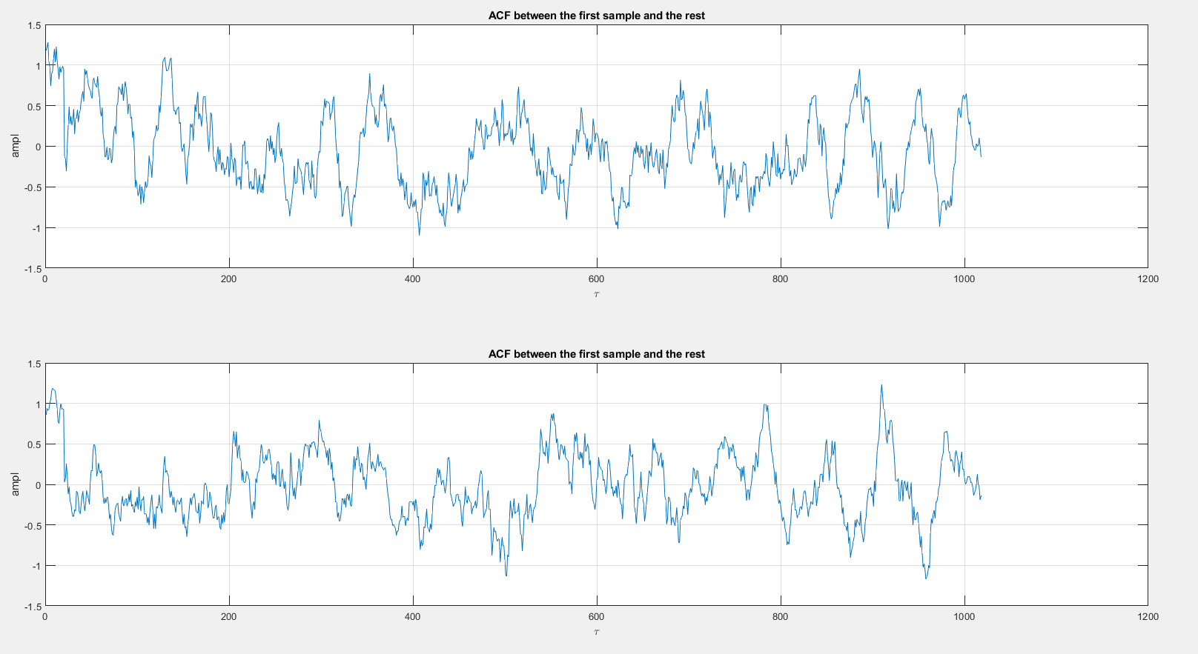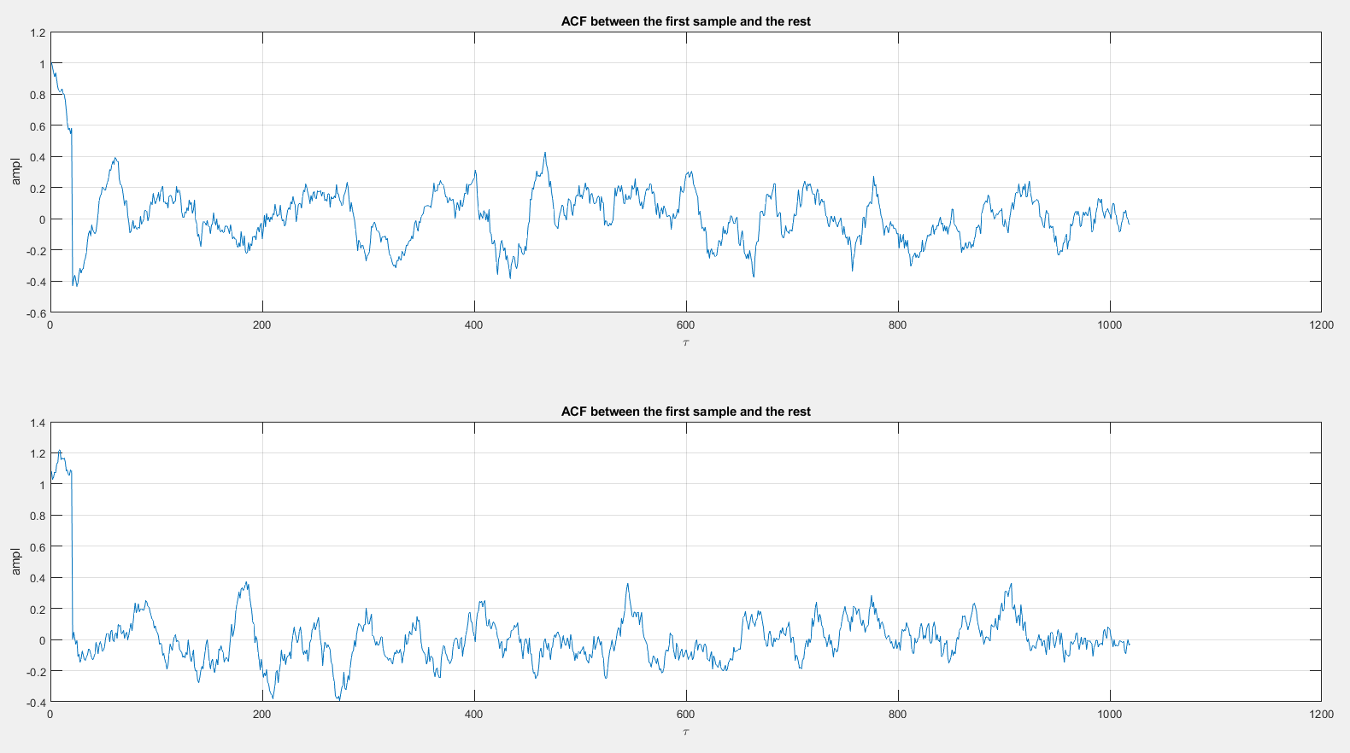

As before the first figure is a one with more wave forms in its ensemble than the one below it. We can see that the when we get closer to 0 the value tends to increase; this is logical because the higher correlation we can get is when we correlate the sample with itself. Again, we can see that when the Tao decreases the correlation increases, this behavior does not change whether we choose the last sample or the first.

We can also deduce that this signal is at least wide sense stationary as the two graphs are so close to each other which indicates that the ACF does not change with time, but changes only with the time difference (Tao).

1. 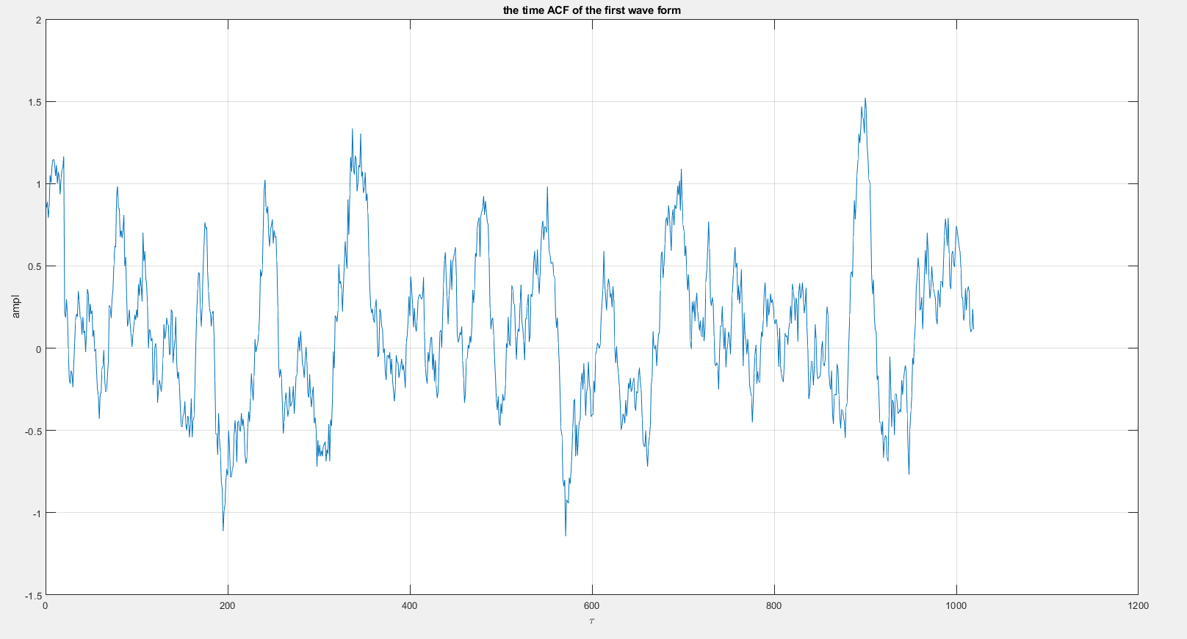**Time ACF and mean:**

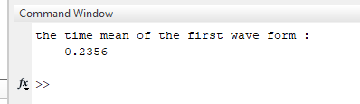

1. **Question 1:**

One can observe that they are some kind of close in value but the non-stability in values makes it hard to say that they are equal (ergodicity).

1. **Question 2:**

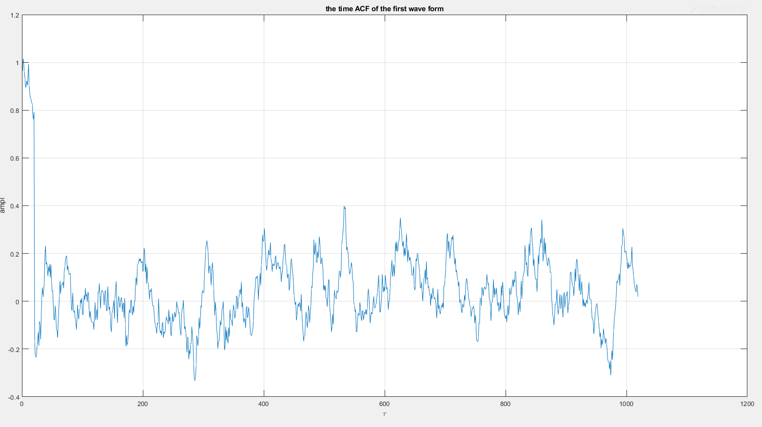

Although both ACFs has the same shape, they vary in the amplitude which make it safe to assume that this signal is not ergodic.